Issue No – IN00364463

Location – Kunshan

Sales Order – 36058132, 36058131

1. POD screen says 4 production orders are in this sales order.

Kunshan Production Report Portal is designed for SOs which have only one POs. This SO has 4.

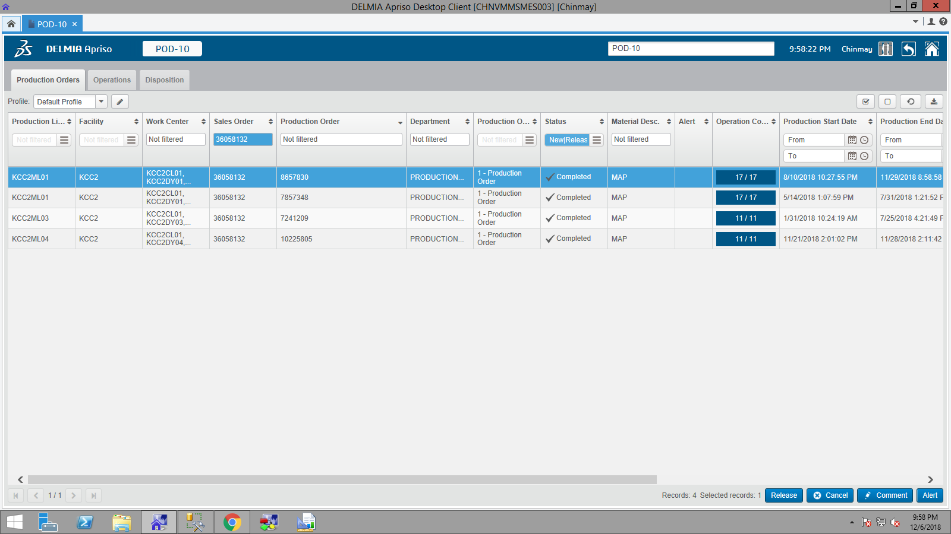

No result came for following order as OprSequenceNo may be mismatched as downtime may be started while order is idle.

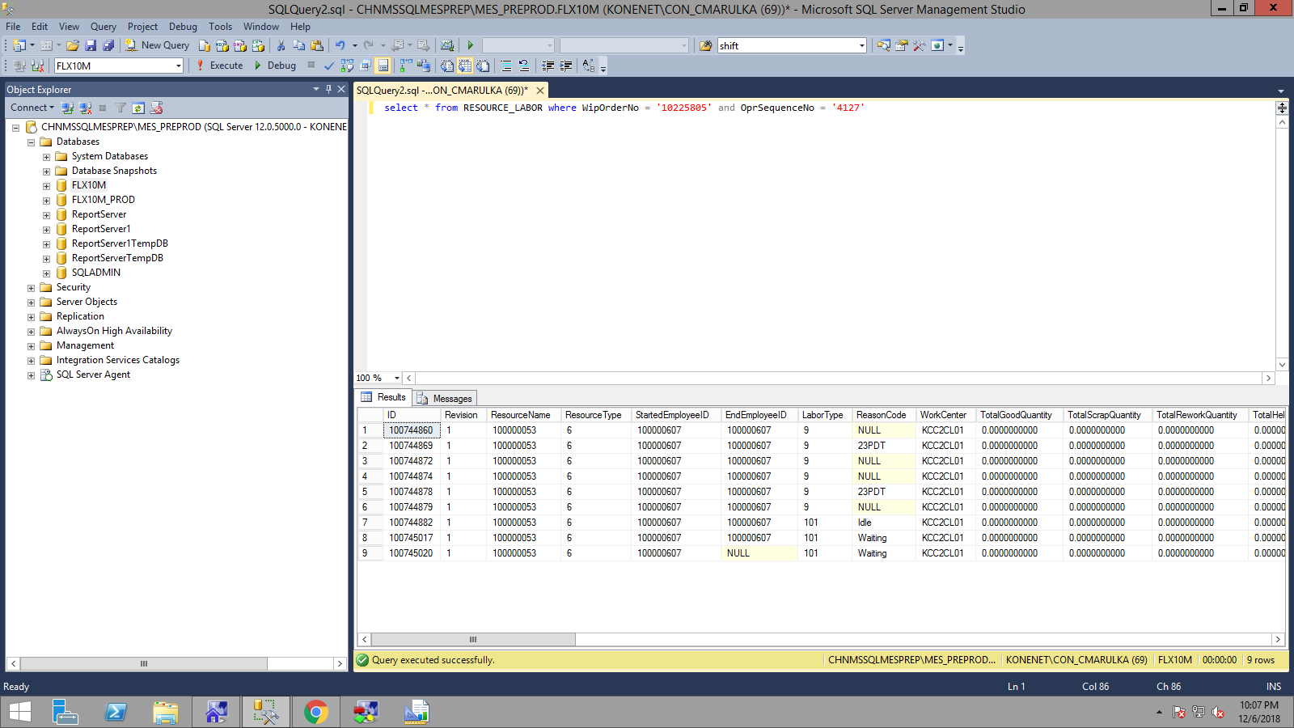

SP used by form to generate document.

**AP_DownTimeProductionReport**

USE [FLX10M]

GO

/****** Object: StoredProcedure [dbo].[AP_DownTimeProductionReport] Script Date: 12/6/2018 10:17:46 PM ******/

SET ANSI_NULLS ON

GO

SET QUOTED_IDENTIFIER ON

GO

ALTER PROCEDURE [dbo].[AP_DownTimeProductionReport]

(

@StartDate DATETIME

,@FinishDate DATETIME

,@ProductionLineNo NVARCHAR(MAX)

,@WorkStation NVARCHAR(MAX)

,@ProductId NVARCHAR(MAX)

,@ProjectCode NVARCHAR(MAX)

,@ReasonCode NVARCHAR(MAX)

,@Shift NVARCHAR(MAX)

,@SalesOrderFilter NVARCHAR(MAX)

,@OrderNo NVARCHAR(MAX)

)

AS

SET NOCOUNT ON;

SELECT DISTINCT

WO.OrderNo AS OrderNo,

WOP.OprSequenceNo AS OprSequenceNo,

WO.ProductionLineNo AS ProductionLine,

R.Name AS WorkStation,

WO.ProductID AS ProductId,

T.Medium,

ISNULL(WO.ProjectCode,'N/A') AS Project,

dbo.AF_GetUTCToLocal(RL.StartTime) AS StartTime,

dbo.AF_GetUTCToLocal(RL.EndTime) AS FinishTime,

CONVERT(decimal(10,2),ROUND(DATEDIFF(ss,RL.StartTime,RL.EndTime)/60.0,2)) AS Duration,

--DATEDIFF(MINUTE,RL.StartTime,RL.EndTime) AS DurationMM,

C.RecordNo DT_Template,

C.RootCauseReasonCode AS ReasonCode,

TRC.Medium AS ReasonCodeTR,

TT.Extended ProblemDescription,

TT2.Extended Solution,

RL.LastUpdatedBy AS Responsibility,

--TTMP.Medium AS DownTimeTemplateName,

CASE RL.OprSequenceNo when '0005' then 'A'

when '0010' then 'B'

when '0020' then 'C'

when '0030' then 'D'

when '0040' then 'E'

when '0050' then 'F'

when '0060' then 'G'

when '0070' then 'H'

when '0080' then 'I'

when '0090' then 'J'

when '0100' then 'K'

when '0110' then 'L'

when '0120' then 'M'

when '0130' then 'N'

when '0140' then 'O'

when '0150' then 'P'

when '0160' then 'R'

when '0170' then 'S'

else 'Z'END SeqOrder,

RWSD.Shift AS Shift,

dbo.AF_GetUTCToLocal(Planned3Y.ExpectedCompletionDate) AS Planned3Y,

--dbo.AF_GetUTCToLocal(Actual3Z.ActualCompletionDate) AS Actual3Z,

--dbo.AF_GetUTCToLocal(Actual3Y.ActualStartDate) AS Actual3Y,

dbo.AF_GetUTCToLocalForTimeZone(1224,Actual3Z.ActualCompletionDate) AS Actual3Z, /*CHANGE fOR TIMEZONE CR */

dbo.AF_GetUTCToLocalForTimeZone(1224,Actual3Y.ActualStartDate) AS Actual3Y, /*CHANGE fOR TIMEZONE CR */

DATEPART(yy,dbo.AF_GetUTCToLocal(Actual3Z.ActualCompletionDate)) AS YearActual3Z,

DATEPART(mm,dbo.AF_GetUTCToLocal(Actual3Z.ActualCompletionDate)) AS MonthActual3Z,

DATEPART(wk,dbo.AF_GetUTCToLocal(Actual3Z.ActualCompletionDate)) AS WeekActual3Z,

DATEPART(dd,dbo.AF_GetUTCToLocal(Actual3Z.ActualCompletionDate)) AS DayActual3Z

FROM

CAPA_PROPERTY_VALUE CPV

JOIN CAPA C ON C.ID=CPV.CAPAID

JOIN AT_RESOURCE_LABOR_RESOURCE_LABOR ARL ON ARL.ParentResourceLaborId=CPV.ValueInt AND CPV.Property='ResourceLaborID'

JOIN RESOURCE_LABOR RL ON RL.ID=ARL.ChildResourceLaborId AND RL.LaborType=9

JOIN REASON_CODE RC ON C.RootCauseReasonCode=RC.ReasonCode

JOIN TEXT_TRANSLATION TRC ON RC.TextID=TRC.TextID AND TRC.LanguageID=1033

JOIN WIP_ORDER WO ON WO.WipOrderNo=RL.WipOrderNo AND WO.WipOrderType=RL.WipOrderType

JOIN WIP_OPERATION WOP ON WOP.WipOrderNo=WO.WipOrderNo AND RL.OprSequenceNo=WOP.OprSequenceNo

JOIN RESOURCE_ R ON R.ResourceName=RL.ResourceName AND R.ResourceType=RL.ResourceType

JOIN PRODUCT P ON P.ID=WO.ProductID

JOIN TEXT_TRANSLATION T ON T.TextID=P.TextID

--JOIN TEXT_TRANSLATION TTMP ON C.TextID=TTMP.TextID

JOIN TEXT_TRANSLATION TT ON TT.TextID=C.RootCauseTextID

JOIN TEXT_TRANSLATION TT2 ON TT2.TextID=C.CorrectiveActionTextID

JOIN EQUIPMENT E ON E.ResourceID=R.ID

CROSS APPLY(SELECT TOP 1 * FROM AT_SHIFT ATS WHERE ATS.WorkCenter=WOP.WorkCenter AND WOP.ActualCompletionDate BETWEEN ATS.StartDateTime AND ATS.EndDateTime) ATSH

JOIN ROTATING_WORK_SCHEDULE_DETAIL RWSD ON ATSH.RotatingScheduleID=RWSD.RotatingScheduleID AND ATSH.DaySequenceNo=RWSD.DaySequenceNo AND ATSH.SequenceNo=RWSD.SequenceNo

CROSS APPLY(SELECT MAX(WOP1.ActualCompletionDate) AS ActualCompletionDate FROM AT_WIP_OPERATION_DETAIL WOP1 WHERE WOP1.WipOrderNo=WOP.WipOrderNo AND WOP1.WipOrderType=WOP.WipOrderType) Actual3Z

CROSS APPLY(SELECT MIN(WOP1.ExpectedCompletionDate) AS ExpectedCompletionDate FROM AT_WIP_OPERATION_DETAIL WOP1 WHERE WOP1.WipOrderNo=WOP.WipOrderNo AND WOP1.WipOrderType=WOP.WipOrderType) Planned3Y

CROSS APPLY(SELECT MIN(WOP1.ActualStartDate) AS ActualStartDate FROM AT_WIP_OPERATION_DETAIL WOP1 WHERE WOP1.WipOrderNo=WOP.WipOrderNo AND WOP1.WipOrderType=WOP.WipOrderType) Actual3Y

WHERE

WO.WorkOrderStatus=3

AND ((WO.OrderNo IN (SELECT val FROM [dbo].[AF_Split_String](@SalesOrderFilter,';')) AND NULLIF(@SalesOrderFilter,'') IS NOT NULL) OR (NULLIF(@SalesOrderFilter,'') IS NULL))

AND Actual3Z.ActualCompletionDate BETWEEN dbo.AF_GetLocalToUTC(@StartDate) AND dbo.AF_GetLocalToUTC(@FinishDate)

AND WO.ProductID IN (SELECT val FROM [dbo].[AF_Split_String](@ProductId,','))

AND R.Name IN (SELECT val FROM [dbo].[AF_Split_String](@WorkStation,','))

AND WO.ProductionLineNo IN (SELECT val FROM [dbo].[AF_Split_String](@ProductionLineNo,','))

AND TRC.Medium IN (SELECT val FROM [dbo].[AF_Split_String](@ReasonCode,','))

AND RWSD.Shift IN (SELECT val FROM [dbo].[AF_Split_String](@Shift,','))

AND ISNULL(WO.ProjectCode,'N/A') IN (SELECT val FROM [dbo].[AF_Split_String](@ProjectCode,','))

ORDER BY

WO.OrderNo, WOP.OprSequenceNo

option (maxdop 1, force order)

Some of the queries that didn’t work.

select CONVERT(decimal(10,2),ROUND(SUM(RegularHours)/60.0,2)) from RESOURCE_LABOR where WipOrderNo = '10225805' and OprSequenceNo = '4127'and ReasonCode = '23PDT'

select StartTime, EndTime,* from RESOURCE_LABOR where WipOrderNo = '10225805' and OprSequenceNo = '4127'and ReasonCode = '23PDT'

select StartTime, EndTime,* from RESOURCE_LABOR where WipOrderNo = '10225805' and OprSequenceNo = '4127'

select sum(ROUND(DATEDIFF(ss,StartTime,EndTime)/60.0,2)) from RESOURCE_LABOR where WipOrderNo = '10225805' and OprSequenceNo = '4127'

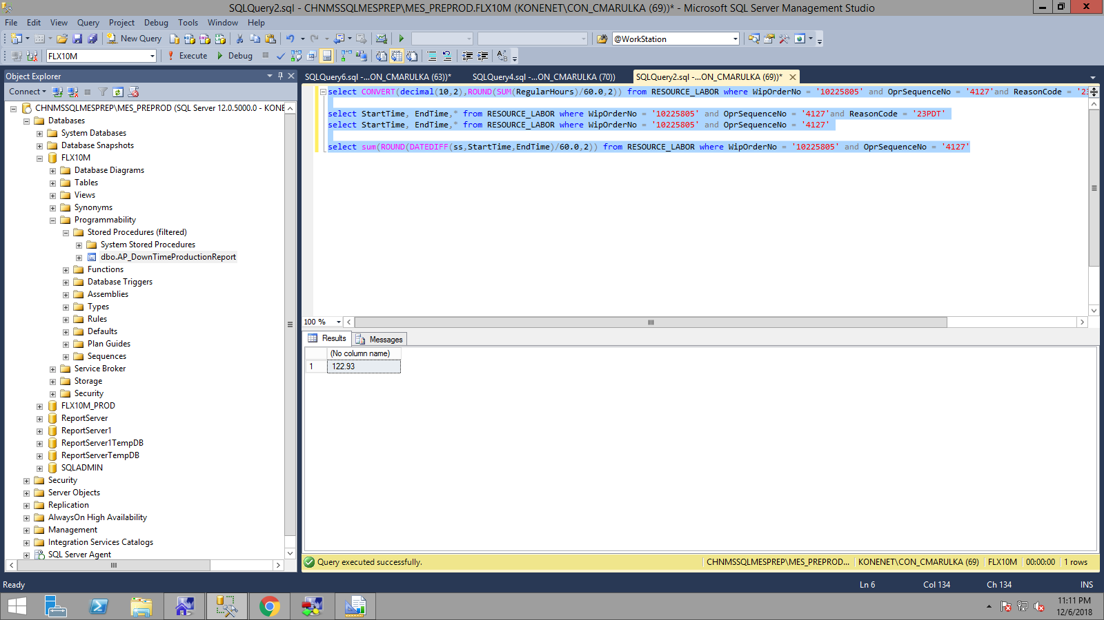

2018-11-26 10:50:21.297

2018-11-26 10:51:34.657

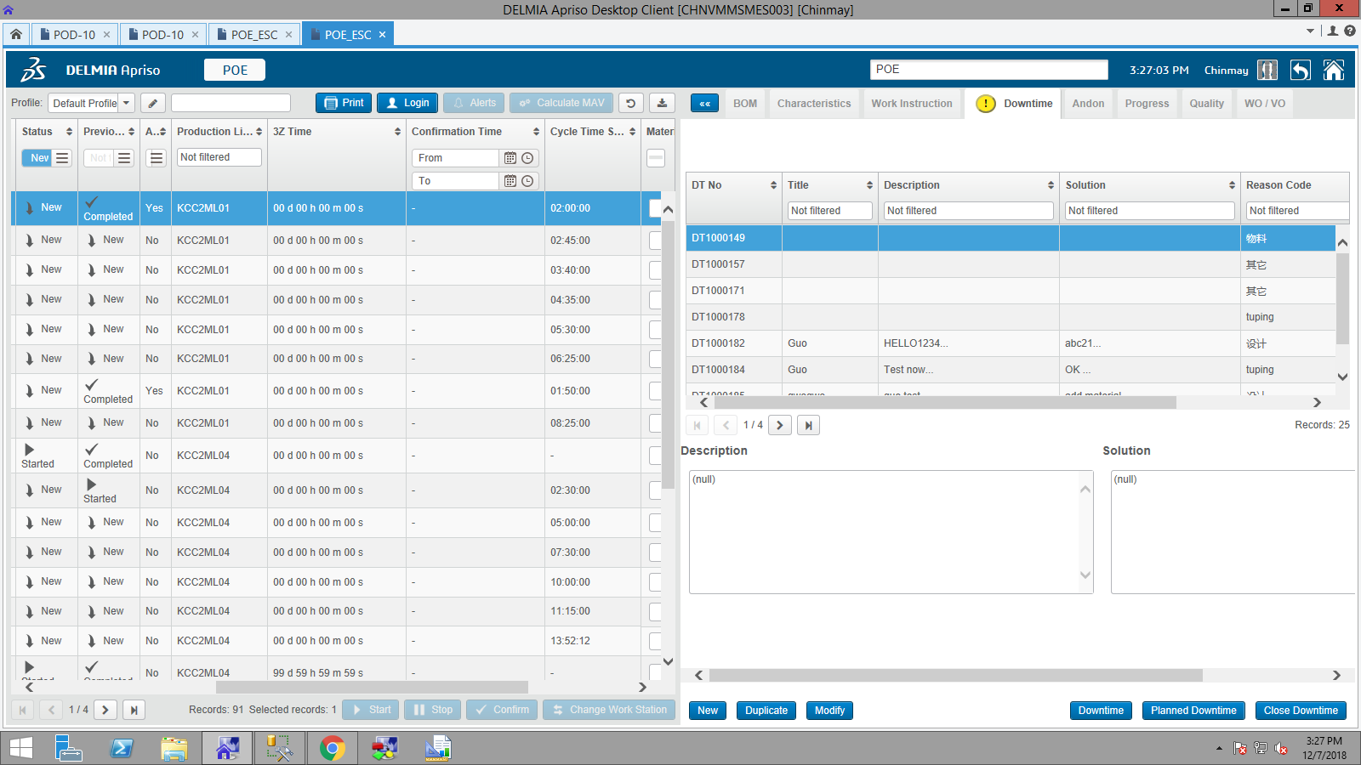

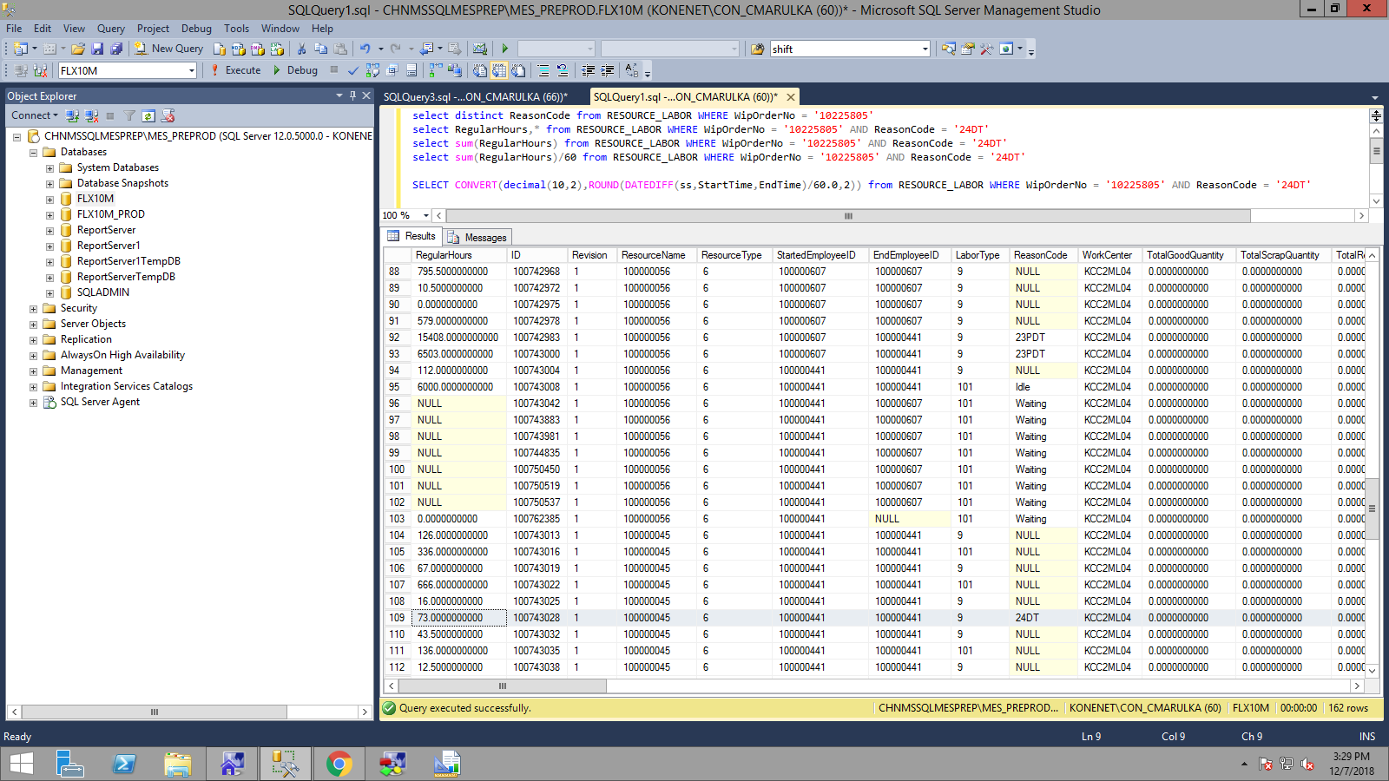

select distinct ReasonCode from RESOURCE_LABOR WHERE WipOrderNo = '10225805'

select RegularHours,* from RESOURCE_LABOR WHERE WipOrderNo = '10225805' AND ReasonCode = '24DT'

select sum(RegularHours) from RESOURCE_LABOR WHERE WipOrderNo = '10225805' AND ReasonCode = '24DT'

select sum(RegularHours)/60 from RESOURCE_LABOR WHERE WipOrderNo = '10225805' AND ReasonCode = '24DT'

SELECT CONVERT(decimal(10,2),ROUND(DATEDIFF(ss,StartTime,EndTime)/60.0,2)) from RESOURCE_LABOR WHERE WipOrderNo = '10225805' AND ReasonCode = '24DT'

10225805

\

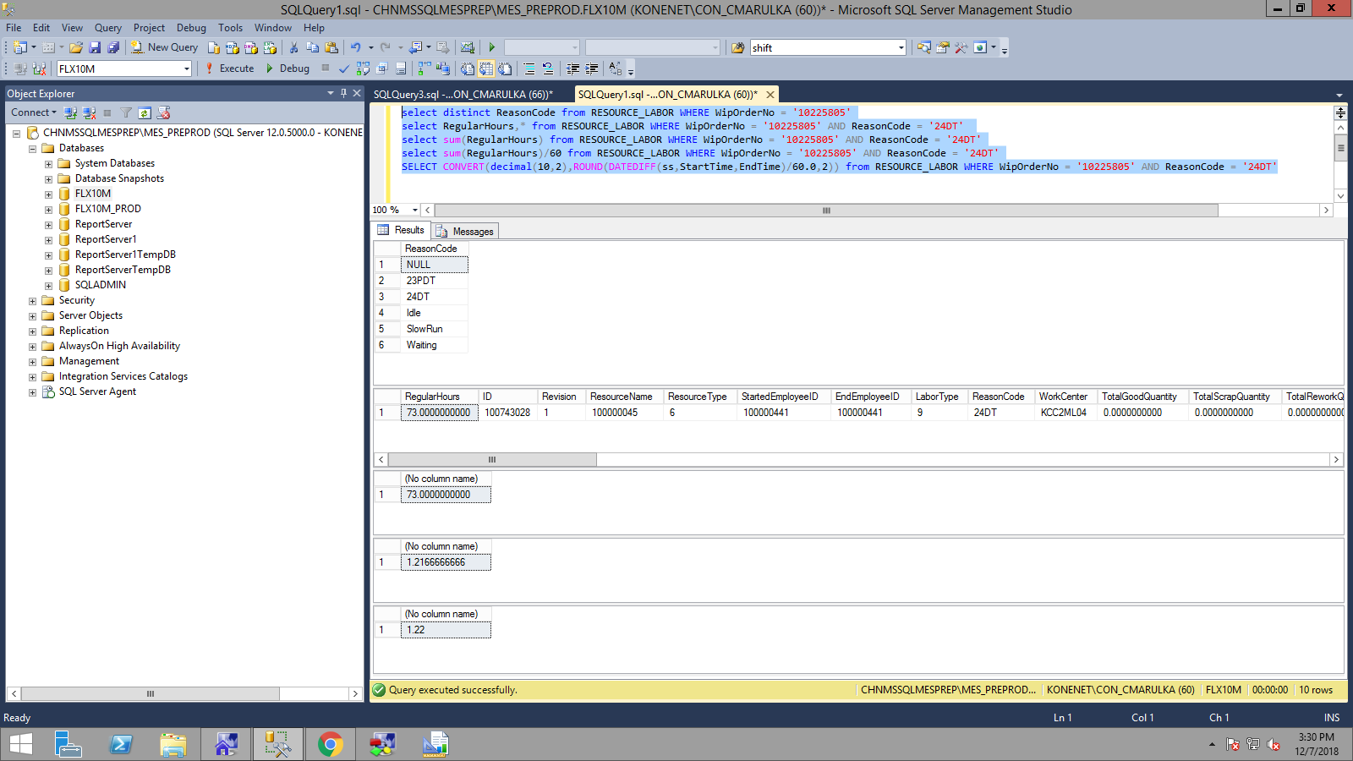

select StartTime,StartedEmployeeID,EndTime,EndEmployeeID,RegularHours,CONVERT(decimal(10,2),ROUND(DATEDIFF(ss,StartTime,EndTime)/60.0,2)) from RESOURCE_LABOR where WipOrderNo = '10185222' AND ReasonCode = '24DT' order by ID DESC

|  |  |  |  |  |  |
| --- | --- | --- | --- | --- | --- |
| StartTime | Started Employee | EndTime | EndEmployeeID | RegularHours | Converting and Rounding Off |
| 2018-10-17 00:10:36.36 | 100000109 | 2018-10-17 00:16:09.09 | 100000109 | 332 | 5.53 |
| 2018-10-17 00:07:48.48 | 100000109 | 2018-10-17 00:10:36.36 | 100000203 | 168 | 2.8 |
| 2018-10-17 00:07:32.32 | 100000109 | 2018-10-17 00:07:48.48 | 100000164 | 16 | 0.27 |
| 2018-10-17 00:07:23.23 | 100000109 | 2018-10-17 00:07:32.32 | 100000088 | 9 | 0.15 |
| 2018-10-17 00:06:56.56 | 100000109 | 2018-10-17 00:07:23.23 | 100000085 | 28 | 0.47 |
| 2018-10-17 00:06:50.50 | 100000109 | 2018-10-17 00:06:56.56 | 100000313 | 5 | 0.08 |
| 2018-10-17 00:06:31.31 | 100000109 | 2018-10-17 00:06:50.50 | 100000088 | 19 | 0.32 |
| 2018-10-17 00:05:53.53 | 100000109 | 2018-10-17 00:06:31.31 | 100000313 | 38 | 0.63 |
| 2018-10-17 00:05:15.15 | 100000109 | 2018-10-17 00:05:53.53 | 100000085 | 39 | 0.65 |
| 2018-10-17 00:04:42.42 | 100000109 | 2018-10-17 00:05:15.15 | 100000313 | 32 | 0.53 |
| 2018-10-17 00:03:47.47 | 100000109 | 2018-10-17 00:04:42.42 | 100000313 | 56 | 0.93 |
| 2018-10-17 00:03:23.23 | 100000109 | 2018-10-17 00:03:47.47 | 100000085 | 24 | 0.4 |
| 2018-10-17 00:03:14.14 | 100000109 | 2018-10-17 00:03:23.23 | 100000292 | 8 | 0.13 |
| 2018-10-17 00:03:03.03 | 100000109 | 2018-10-17 00:03:14.14 | 100000164 | 12 | 0.2 |
| 2018-10-17 00:01:48.48 | 100000109 | 2018-10-17 00:03:03.03 | 100000311 | 74 | 1.23 |
| 2018-10-17 00:01:30.30 | 100000109 | 2018-10-17 00:01:48.48 | 100000313 | 18 | 0.3 |
| 2018-10-17 00:01:25.25 | 100000109 | 2018-10-17 00:01:30.30 | 100000575 | 5 | 0.08 |
| 2018-10-17 00:00:03.03 | 100000109 | 2018-10-17 00:01:25.25 | 100000088 | 82 | 1.37 |
| 2018-10-16 23:59:56.56 | 100000109 | 2018-10-17 00:00:03.03 | 100000115 | 7 | 0.12 |
| 2018-10-16 23:54:43.43 | 100000109 | 2018-10-16 23:59:56.56 | 100000386 | 314 | 5.23 |
| 2018-10-16 23:54:13.13 | 100000109 | 2018-10-16 23:54:43.43 | 100000622 | 29 | 0.48 |
| 2018-10-16 23:52:48.48 | 100000109 | 2018-10-16 23:54:13.13 | 100000622 | 85 | 1.42 |
| 2018-10-16 23:45:32.32 | 100000109 | 2018-10-16 23:52:48.48 | 100000622 | 436 | 7.27 |

